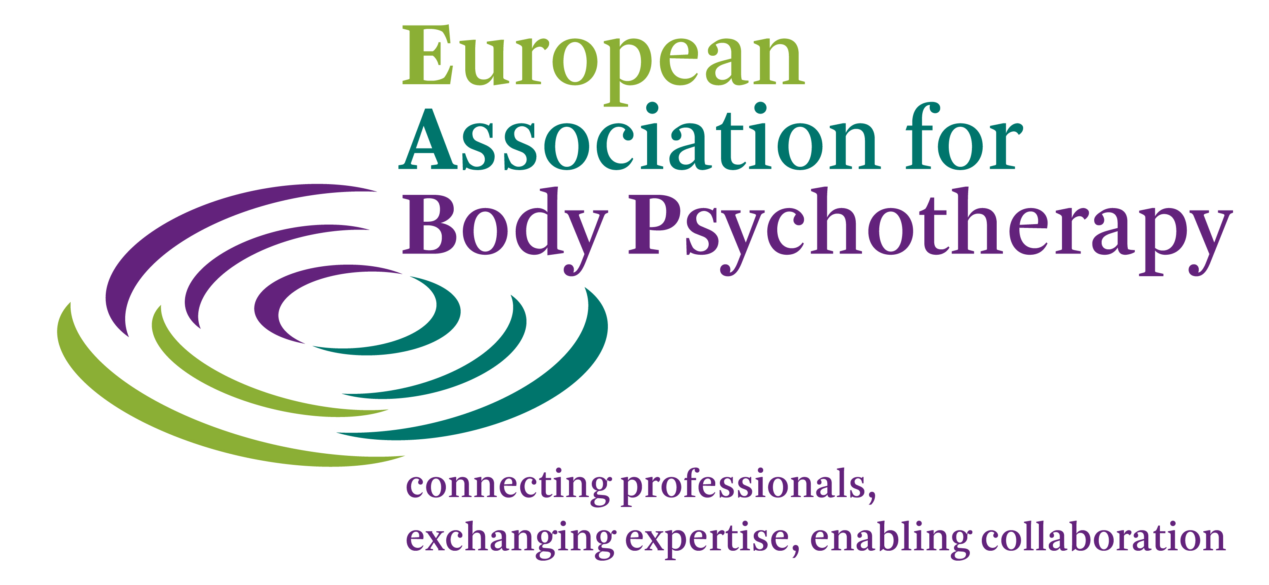

# **APPLICATION FORM - EABP STUDENT**[1] **MEMBERSHIP**

Please inform yourself about the [Student Membership Criteria and Conditions](http://www.eabp.org/membership-student.php) and use the instructions for filling in this application form.

|  |  |
| --- | --- |
| **PERSONAL DATA** | |
| **Name:** |  |
| **Contact Address:** |  |
|  |
|  |
| Tel: (including country code) |  |
| Email: |  |
| Website: |  |
| **Personal Details:** |  |
| Date of birth: |  |
| Sex: |  |
| Languages spoken: |  |
| Nationality: |  |
| Profession (s): |  |
| Other Education: |  |
| **My reasons for applying** |  |
| (a) I am in training in Body-Psychotherapy and have not yet fulfilled the full criteria for membership of EABP. |  |
| Training Institute: |  |
| Website: |  |
| (b) I am a student from: |  |
| the social science faculties |  |
| psychology |  |
| medicine |  |
| social worker |  |
| University & Faculty |  |
| Website: |  |

I wish to apply for Student Membership of EABP.

Signed: Date: Place:

**Please email your application to:**

**EABP Secretariat,** [**secretariat@eabp.org**](mailto:secretariat@eabp.org)

**or to the Secretary of the** [**National Association**](http://www.eabp.org/national-associations.php) **of the country in which you live.**

**Please provide proof of where you are a student.**

**On acceptance of membership you will be sent an invoice for the yearly Membership Fee of**

**30 Euros. When your fee has been paid you will be entered in the Membership database on the EABP (and/or National Association) website (s).**

1. Student Membership is open to students from body-psychotherapy Training Institutes. It is for a period of 5 years. It is also open to students from the social science faculties – psychology and medicine, social workers with an age limit of 28.